BCV Show Entry Form 2018
Step By Step Instructions to enter birds into shows either by Australia Post or Electronic Email.
- How to Download the BCV Entry Form:
• Go to the BCV website – www.bcv.asn.au
• On the front page is a heading “Budgerigar Shows” – Click on this
• Click on “Diploma Show Entry Form” – this opens in Microsoft Excel.
• The Form Opens. Click on File, Save As and select “Desktop” and then “Save”
• It will be saved as BCV_SHOW_ENTRY_FORM_JAN?? (?? Is year).
• This can be used for all shows you enter for that year.

- Filling out the BCV Show Entry Form
• Open the document. (from where you saved it)
• The entry form has the Show Classes listed on the left side, on the right side is the show form for you to complete.
• You can now type directly onto the BCV Show entry form – Show section.
• Please complete all Exhibitor sections where possible. This will help the club representative to make contact if required.
• All entries are to be listed as single entries under the heading - Class: Example shown below.
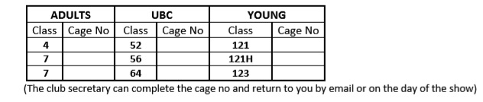
• Leave the Cage No: BLANK
• Complete the total number of entries for ADULT, UBC & YOUNG at the bottom of the form.
- Sending completed form to the Club Secretary
• The completed form is ready to be sent to the Club Secretary by post or email.
• If posting: - Open the document and select Print. Please post the completed show form to the club secretary at least 5 days before the show. (i.e.: Post by the Monday before the show date to ensure the club receives the form on time.)
• If emailing: There are 2 Parts.
• PART 1 – Ensure the show form is open and completed. Click On the top left corner of your document “File” and in the drop-down list “Save As”. Name it as follows “DandenongFebruary” or the Club where the Show is and click Save.
• Part 2 – Once Saved right click on the saved file and in the menu box click on Send To. This will give you the option to select “Mail Recipient”. Click this and it will automatically attach the file to an email. Put in the email address of the Show Secretary, send a courteous note and supply your phone number for any issues and click “Send”. Job Done!
• A club rep may email your form back to you with Cage No’s or give it to you on Show Day.

