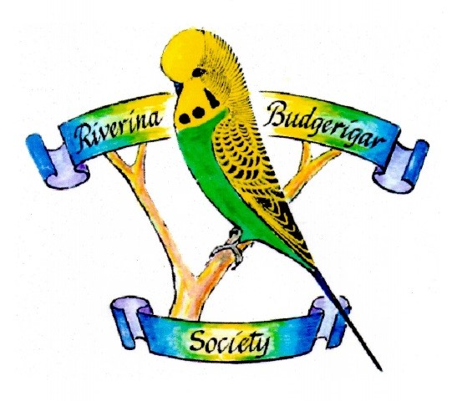President – Malcolm Randall
0427 387 441
murrabahsalers@live.com.au

Secretary – Rob Randall
RMB 1540 Fullers Rd Tocumwal NSW 2714
randall6@hotmail.com

Treasurer – Ken Brown
Diploma Show/Auction Venue – Barooga Community Centre
Club Meetings – 3rd Thursday of the month at 7:30pm

