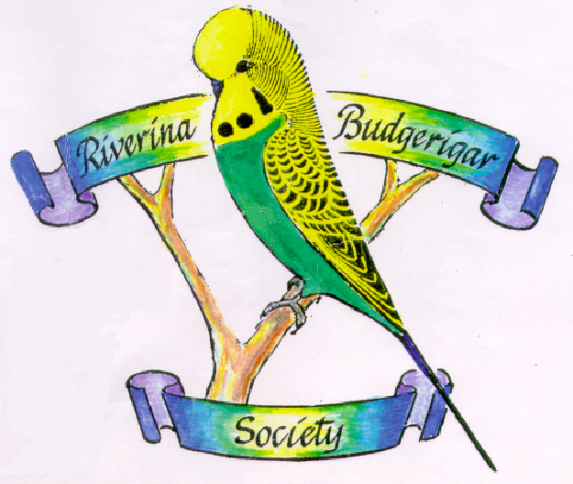

President – Malcolm Randall
(03) 5883 9258 – 0427 387 441
murrabahangus@live.com.au

Secretary – Rob Randall
RMB 1540 Fullers Rd Tocumwal NSW 2714
0438 095 995
randall6@hotmail.com
Treasurer – Ken Brown
Diploma Show/Auction Venue – Barooga Community Centre
Club Meetings – 3rd Thursday of the month at 7:30pm

