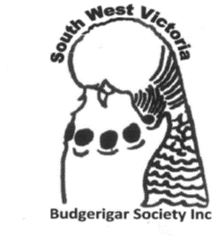
South West Budgerigar Society

President | Peter Owen | peteowen22@hotmail.com | 0400 233 396
Vice President | Kaylee Fisher | dkfisher@westvic.com.au | 0423 627 356
Secretary | Tim Paterson | timbo_pat@hotmail.com | 0424 978 568
Treasurer | Peter Owen | peteowen22@hotmail.com | 0400 233 396
Councillor | Neil Fitzgibbon
Councillor | Ray Slade

South West Budgerigar Society inc.
21 Edgar st. Heywood 3304

