Budgerigar Council of Victoria Inc.
Minutes of Meeting

Meeting: | BCV June Meeting.
Date: | 21 July 2021

- Committee Members Attendance |  | Jan |  | Feb | Mar |  | Apr | May |  | Jun | Jun | Jul | Aug | Sep | Oct | Nov | Dec | Total = 12
President, Peter Thurn |  | Y |  | Y | Y |  | Y | Y |  | Y | Y | Y |  |  |  |  |  | 8
Vice President, Malcolm Randall |  | Y |  | Y | Y |  | Y | Y |  | Y | Y | Y |  |  |  |  |  | 8
Secretary, Ray Slade |  | Y |  | Y | Y |  | Y | Y |  | Y | Y | Y |  |  |  |  |  | 8
Treasurer, Martin Paoli |  | A |  | Y | Y |  | Y | Y |  | Y | Y | Y |  |  |  |  |  | 7
Ring Registrar, Darren Macfarlane |  | Y |  | Y | A |  | Y | Y |  | Y | A | Y |  |  |  |  |  | 6
Show Manager/Judges & Stand, James Bader |  | Y |  | Y | A |  | Y | Y |  | Y | Y | Y |  |  |  |  |  | 7
Shield Secretary, Rod Turnbull |  | Y |  | Y | Y |  | Y | A |  | Y | A | Y |  |  |  |  |  | 6
Budgie News Editor, James Smith |  | Y |  | Y | Y |  | Y | Y |  | Y | Resign |  |  |  |  |  |  | 6
New Member Coordinator, Amanda Fonti |  | Y |  | Y | Y |  | Y | Y |  | Y | Y | A |  |  |  |  |  | 7
Councillor, Richard Hiscock |  | A |  | Y | A |  | Y | Y |  | Y | A | Y |  |  |  |  |  | 5
Councillor, Alistair Bennallack |  | Y |  | Y | Y |  | Y | A |  | Y | Y | Y |  |  |  |  |  | 7
Councillor, Rod Skivington |  | Y |  | Y | Y |  | Y | Y |  | Y | Y | Y |  |  |  |  |  | 7
Councillor, Col Flanagan |  | Y |  | Y | Y |  | Y | Y |  | A | Y | Resign |  |  |  |  |  | 6
Councillor, Heath Chasemore |  |  |  |  |  |  |  |  |  |  |  | Y |  |  |  |  |  | 1
Councillor, Derrin Ray |  |  |  |  |  |  |  |  |  |  |  | Y |  |  |  |  |  | 1
Attendance Total |  | 10 |  | 13 | 9 |  | 12 | 11 |  | 12 | 9 | 12
Time commences: | 7.39pm |  |  |  |  | Recorder: |  |  | Ray Slade
2. Confirmation of previous minutes: |  |  | Motion Moved by M Randall that the minutes of the previous meeting held on 16 June 2021 having been previously circulated were taken as being correct. 2nd A Bennallack.

- Presidents Report
43 1 | Report Updated | P Thurn reported that the mail chimp was sent to all members with an update from council including the June minutes. Stats form the send out were  - 1 unsubscribed  - 1 bounced  - 175 opened out of the 272 sent  - 14 clicked through to the minutes.  Will be good to keep this going but keep it light and informative.  There is still one position vacant on council.  There were some auctions conducted before COVID lockdown. The dinner before the Riverina auction was well attended. At the Melton auction the police turned up to check if all COVID protocols were adhered to. There are some concerns with the next few events going ahead due to COVID.
- Secretary Report
4.1 | Correspondence In | Agenda for extra meeting on 30 June  James Smith resignation from council  Various emails from councillor Re Marketing  M Paoli update email addresses  H Chasemore expression of interest of vacant council position  D Ray expression of interest of vacant council position.  C Flanagan resignation from council  Consumer Affairs tax invoice for financial statement and changes to Rules Of Association.  M Paoli Financials  Vanessa White & R Turnbull Re third prize for Rainbows  Brett Ricardo Change of Bendigo auction date  D Macfarlane Ring report  D Macfarlane Staging trailer & staging  M Randall staging quote  P Thurn update Event Schedule  P Thurn New Website  Various emails form councillors Re Website  Leigh Downey, He has 2023 Logies.
4.2 | Correspondence Out | J Smith asking for secretarial hand over.  M Paoli Re Consumer Affairs invoice  H Chasemore & D Ray acceptance of their expressions of interest in vacant council positions  Letter to Aussie Seeds  Minutes to councilor’s  Redacted minutes to P Thurn  J Smith BCV Computer.
- Treasurers Report
5.1 | Report Update | Martin Paoli circulated the report to all councillors prior to the meeting. The cheque to Cawartha College was cancelled and a new one issued.  Total payment $26,068.40  Motion Moved by R Hiscock that the outstanding payments of $26,068.40 for the items listed in payments approval be paid. 2nd by R Skivington. Carried  There is a term deposit to mature at the end of July. M Paoli staed he wanted to merge the national account with the term deposit.  A third signatory needs to be added to the account.
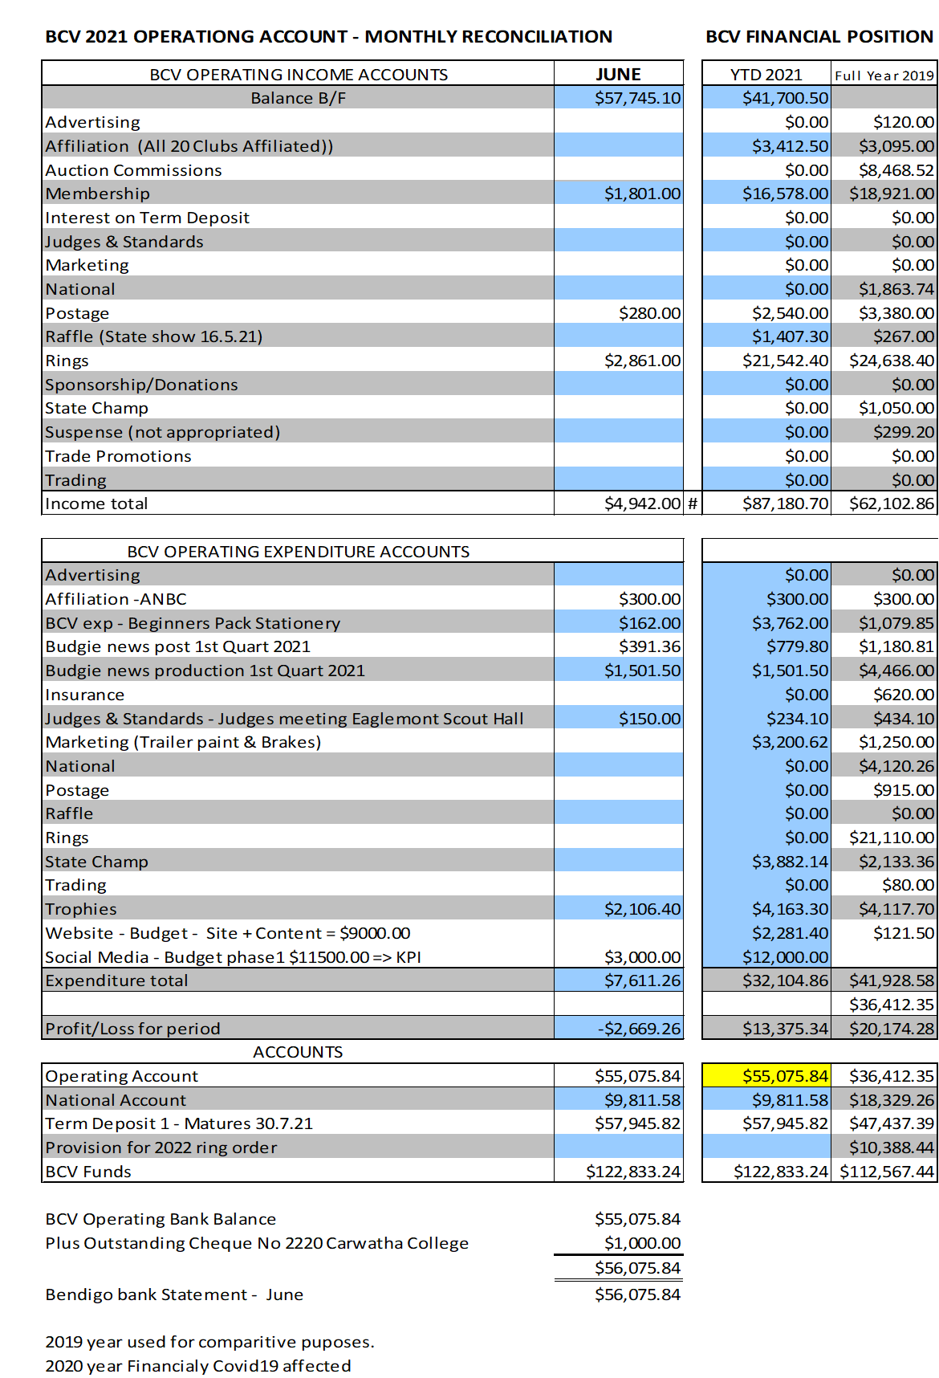
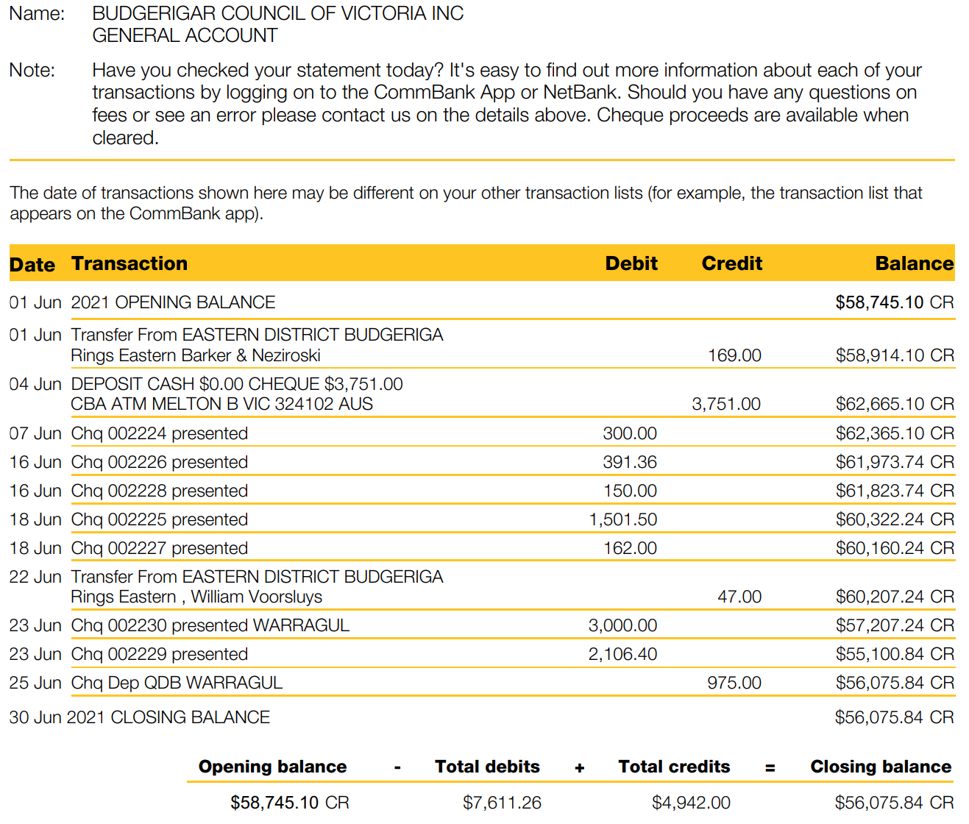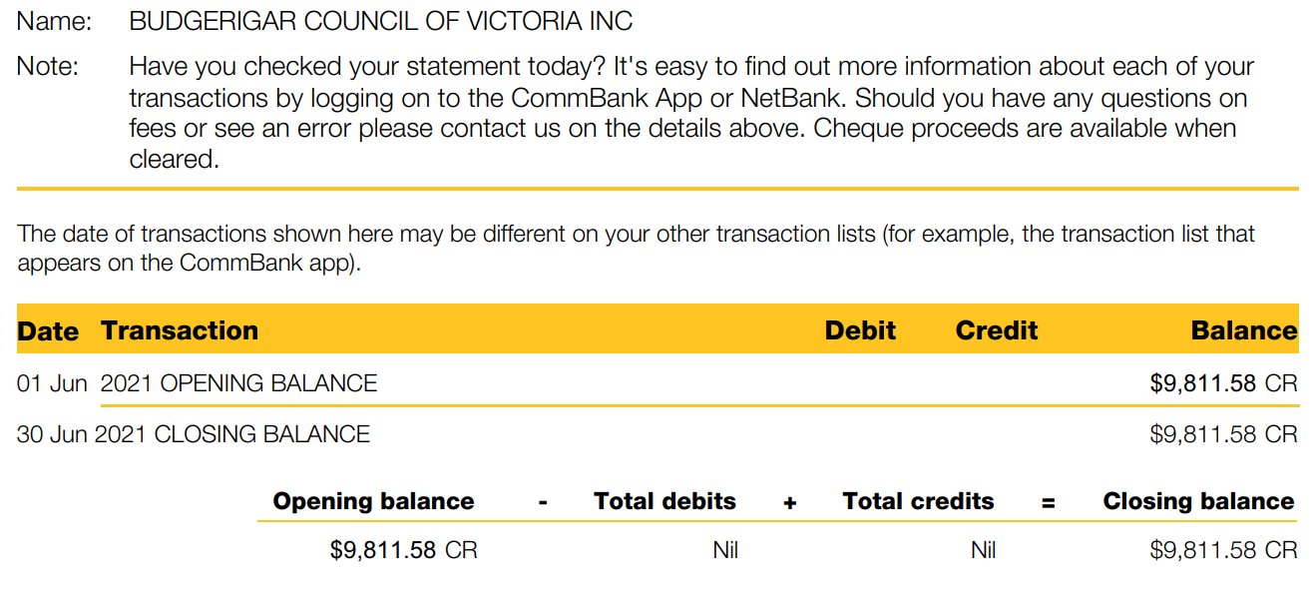
Item | Topic | Discussion | Action | Responsible / Timeframe
- Points Report
6.1 | Report Update | M Randall had nothing to report.
- Ring Register
7.1 | Report Update | D Macfarlane presented the ring report.  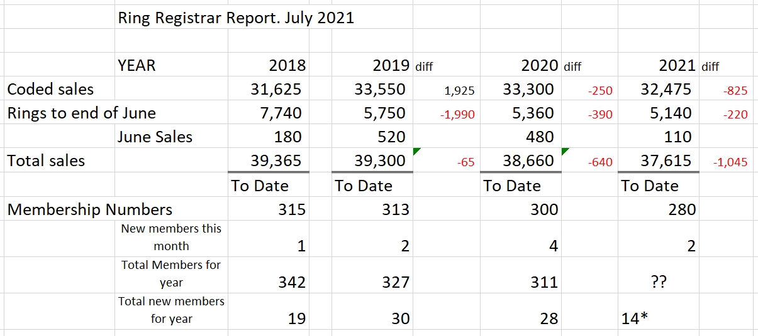
- Budgie News
8.1 | Report Update | R Turnbull has done the actions from the minutes and has got the photos done and is part way through the judges’ comments.  P Thurn has got a running sheet from M Emond as to what he is looking for. He will continue to work with M Emond to get the magazine out. From here we can get a cost from Bart N Print for collating the magazine. P Thurn circulated a council report rather than a presidents report he has written for the budgie news magazine. Councillors agreed that it was a good idea. Some things that D Macfarlane raised in his responding email to councillors should be stand alone items in the magazine. A profile of the two new councillors for the magazine.  D Ray to approach Vanessa White to do satirical cartoons for the magazine.  Articles from Budgie World and from other states can be used.
- Judges & Standards
9.1 | Report Updated | J Bader had nothing to report.
- Show Secretary
10.1 | Report Updated | R Turnbull had nothing new to report. The UBC Show will be planed for but may not go ahead due to COVID restrictions.
- New Membership Coordinator
11.1 | Report Updated | A Fonti is an apology but reported to P Thurn that there were two new members for the last month.  A Fonti reported that some new member surveys had been returned.
- Social Media
12.1 | Report Updated | P Thurn reported he had a two meeting with T Suafoa to sort content of the new website.  It was decided there were three categories 1. Not negotiable 2. Nice to have 3. Park at the back of the website.  Master of Digital will take the content across to new website and BCV get to decide where to put it at no additional cost.  Admin rites can be given to whomever is decided upon by the council. Suggested that P Thurn, R Turnbull, M Randall R Slade have access for relevant content update.  28 July is when the next iteration for the website is due. It will be distributed to all councillors and a decision made if another special meeting is convened.  A Bennallack reported that there are 125 Instagram posts already prepared of which 26 had gone out and that council is comfortable that we continue with them. Council agreed to continue with the Instagram posts. For the Facebook posts T Suafoa would like to do member profiles showing their aviaries. A Bennallack to distribute the spread sheet from T Suafoa to councillors.  T Suafoa’s contract expires at the end of August.  R Hiscock proposed that the BudgieVic Facebook page come under the umbrella of the BCV Facebook page.  A Motion was moved by R Hiscock that the contract of T Suafoa be terminated at the end of August as per the contract. 2nd by M Paoli. 3 voted for the motion and 9 voted against the motion. Motion was defeated.  P Thurn summing up stated that at the special meeting council agreed to continue with T Suafoa’s contact due to the brief that she was originally given. She will now put a greater focus on postings on Facebook that targets a different group of people. There is a two week clause in the contract and this can be activated at any time.
- ANBC Report.
13.1 | Report Update | P Thurn reported that Victoria has the nationals in 2023. A new organising committee will need to be formed. The venue at Bendigo is still in consideration. R Slade has been making enquiries with venues that may be suitable for the national event.
 | Reports Approval | Motion Moved by R Turnbull that the reports be approved 2nd D Macfarlane.
14. General Business Items
15.1 | Consumer Affairs | R Slade reported that the 2020 financial report and the amendments to the Rule of Association as voted upon at the AGM has been lodged with Consumer Affairs. There have been no financial reports lodged for the previous two years. The delegates have been revised to include P Thurn and M Paoli. Motion moved by R Turnbull that R Slade update the financial reports for 2019 and 2018 with Consumer Affairs. 2nd R Hiscock. Carried.
15.2 | Rainbow Class Prizes | Robin Kirby first prize a voucher form Paws and Pastels. Address for R Turnbull  Rex Stephens second prize Gold Class movie voucher. Address for A Bennallack.  Jen Jewel Brown third prize voucher to trade stand.
15.3 | BCV Computer | The BCV computer has no access to Office 365 and no virus protection.  Motion moved by J Bader that R Slade source an activation of Office 365 on the BCV Computer. 2nd R Turnbull. Carried
15.4 | BudgieVic Logo | R Hiscock has secured the BudgieVic business name and three domain names (BudgieVic.com.au, BidgieVic.net.au & BudgieVictoria.com.au) and will hand over to council. The application to register the logo was lodge in 2019 but lapsed on the 30 April 2021.  There was a discussion on BCV Executive emails
15.5 | Staging Trailer. | R Turnbull presents a staging layout of the hall for the state shows. He believes that staging for 1500 birds is not enough.  J Bader remarked the current staging is not sustainable. It is heavy to move and carry for most members. There is to much wait in the trailers.  D Macfarlane presented a document to councillors with four options for discussion on staging and trailers.  The view in getting new staging was for it to fit into one trailer but with the weight of it there still needs to be two trailers.  M Randall and R Turnbull to work through the cost of the extra staging and two new tradie trailers and report back to the next meeting.
15.6 | Judges Shirts | The decision needs to be made as to what goes on the shirts.  A Motion was moved by D Macfarlane that the new judge’s shirts to be Royal Blue and inscribed with Budgerigar Council of Victoria and BudgieVic. 2nd by M Paoli. Carried.
15.7 | Marketing Trailer Logo | To be held over to August Meeting.
15.8 | Online Auctions | R Hiscock reported that most people are a bit over the online auctions. The BCV should only put club auctions on its Facebook page not individuals’ auctions. The BCV gains no income from these auctions. There should be more posts about winning birds not peoples culls in auctions.  R Turnbull stated that the BCV should not be seen to be supporting interstate auctions and not supporting BCV individual members auctions.  The consensus of the meeting was that there is not much we can do about the auctions online.
15.9 | Green Valley Grains | P Thurn aske M Paoli if he had any updates on contacting Green Valley Grains.  M Paoli has not had any replies to his calls and emails.  P Thurn stated that there is add due in Budgie News for Green Valley Grains and should the add go ahead.  P Thurn requested that the Secretary R Slade send a letter from the BCV requesting detail of the commercial arrangement and the amount of money owed to the BCV.
15.10 | What Success looks like for the BCV | A Bennallack had sent an email around some time back asking councillors what success liked like for the BCV. What it is we are trying to achieve. Add as a future agenda item.

Meeting closed: | 10.37pm
Next meeting: | 18 August 2021 | Commencing at: | 7.30pm | Venue: | Microsoft Teams.

Actions Arising from Minutes
June Committee Meeting
Item | Business arising | Responsible | From Meeting held on | Due Date
12.2 | C Flanagan Comments-  Apology letter to be sent from C Flanagan to L Downey not done. Council decided that P Thurn would write the apology | P Thurn | May 2021 | August 2021
12.4 | Ballarat Show Date-  Liaise with Ballarat for a new date. Still no resolution | R Slade | May 2021` | August 2021
13.3 | Staging Trailer-  Quote and weight for staging to hold 1500 birds. Recalculate quote and weight for 1600 birds | M Randall  R Turnbull | June 2021 | August 2021
11.1 | Show Secretary-  Club secretaries list to R Turnbull | R Slade | July 2021 | August 2021
15.1 | Consumer Affairs-  Update Financials for 2019 & 2018 with Consumer Affairs | R Slade | July 2021 | August 2021
15.4 | Budgivic Logo-  Investigate Executive emails | R Slade | July 2021 | August 2021.
15.6 | Judges Shirts-  Shirts, vest, and tie to be ordered for all judges | M Paoli | July 2021 | August 2021
15.9 | Green Valley Grain-  Letter to be sent to from BCV | R Slade | July 2021 | August 2021

