Building a Budgerigar stud.
President - Col Flanagan
In the beginning Bruce Shepard & Colin Flanagan showed separately. It was not until the importation of the birds from the UK that they formed the partnership and began to work much closer, although for a long time earlier birds were exchanged regularly at the time of pairing.
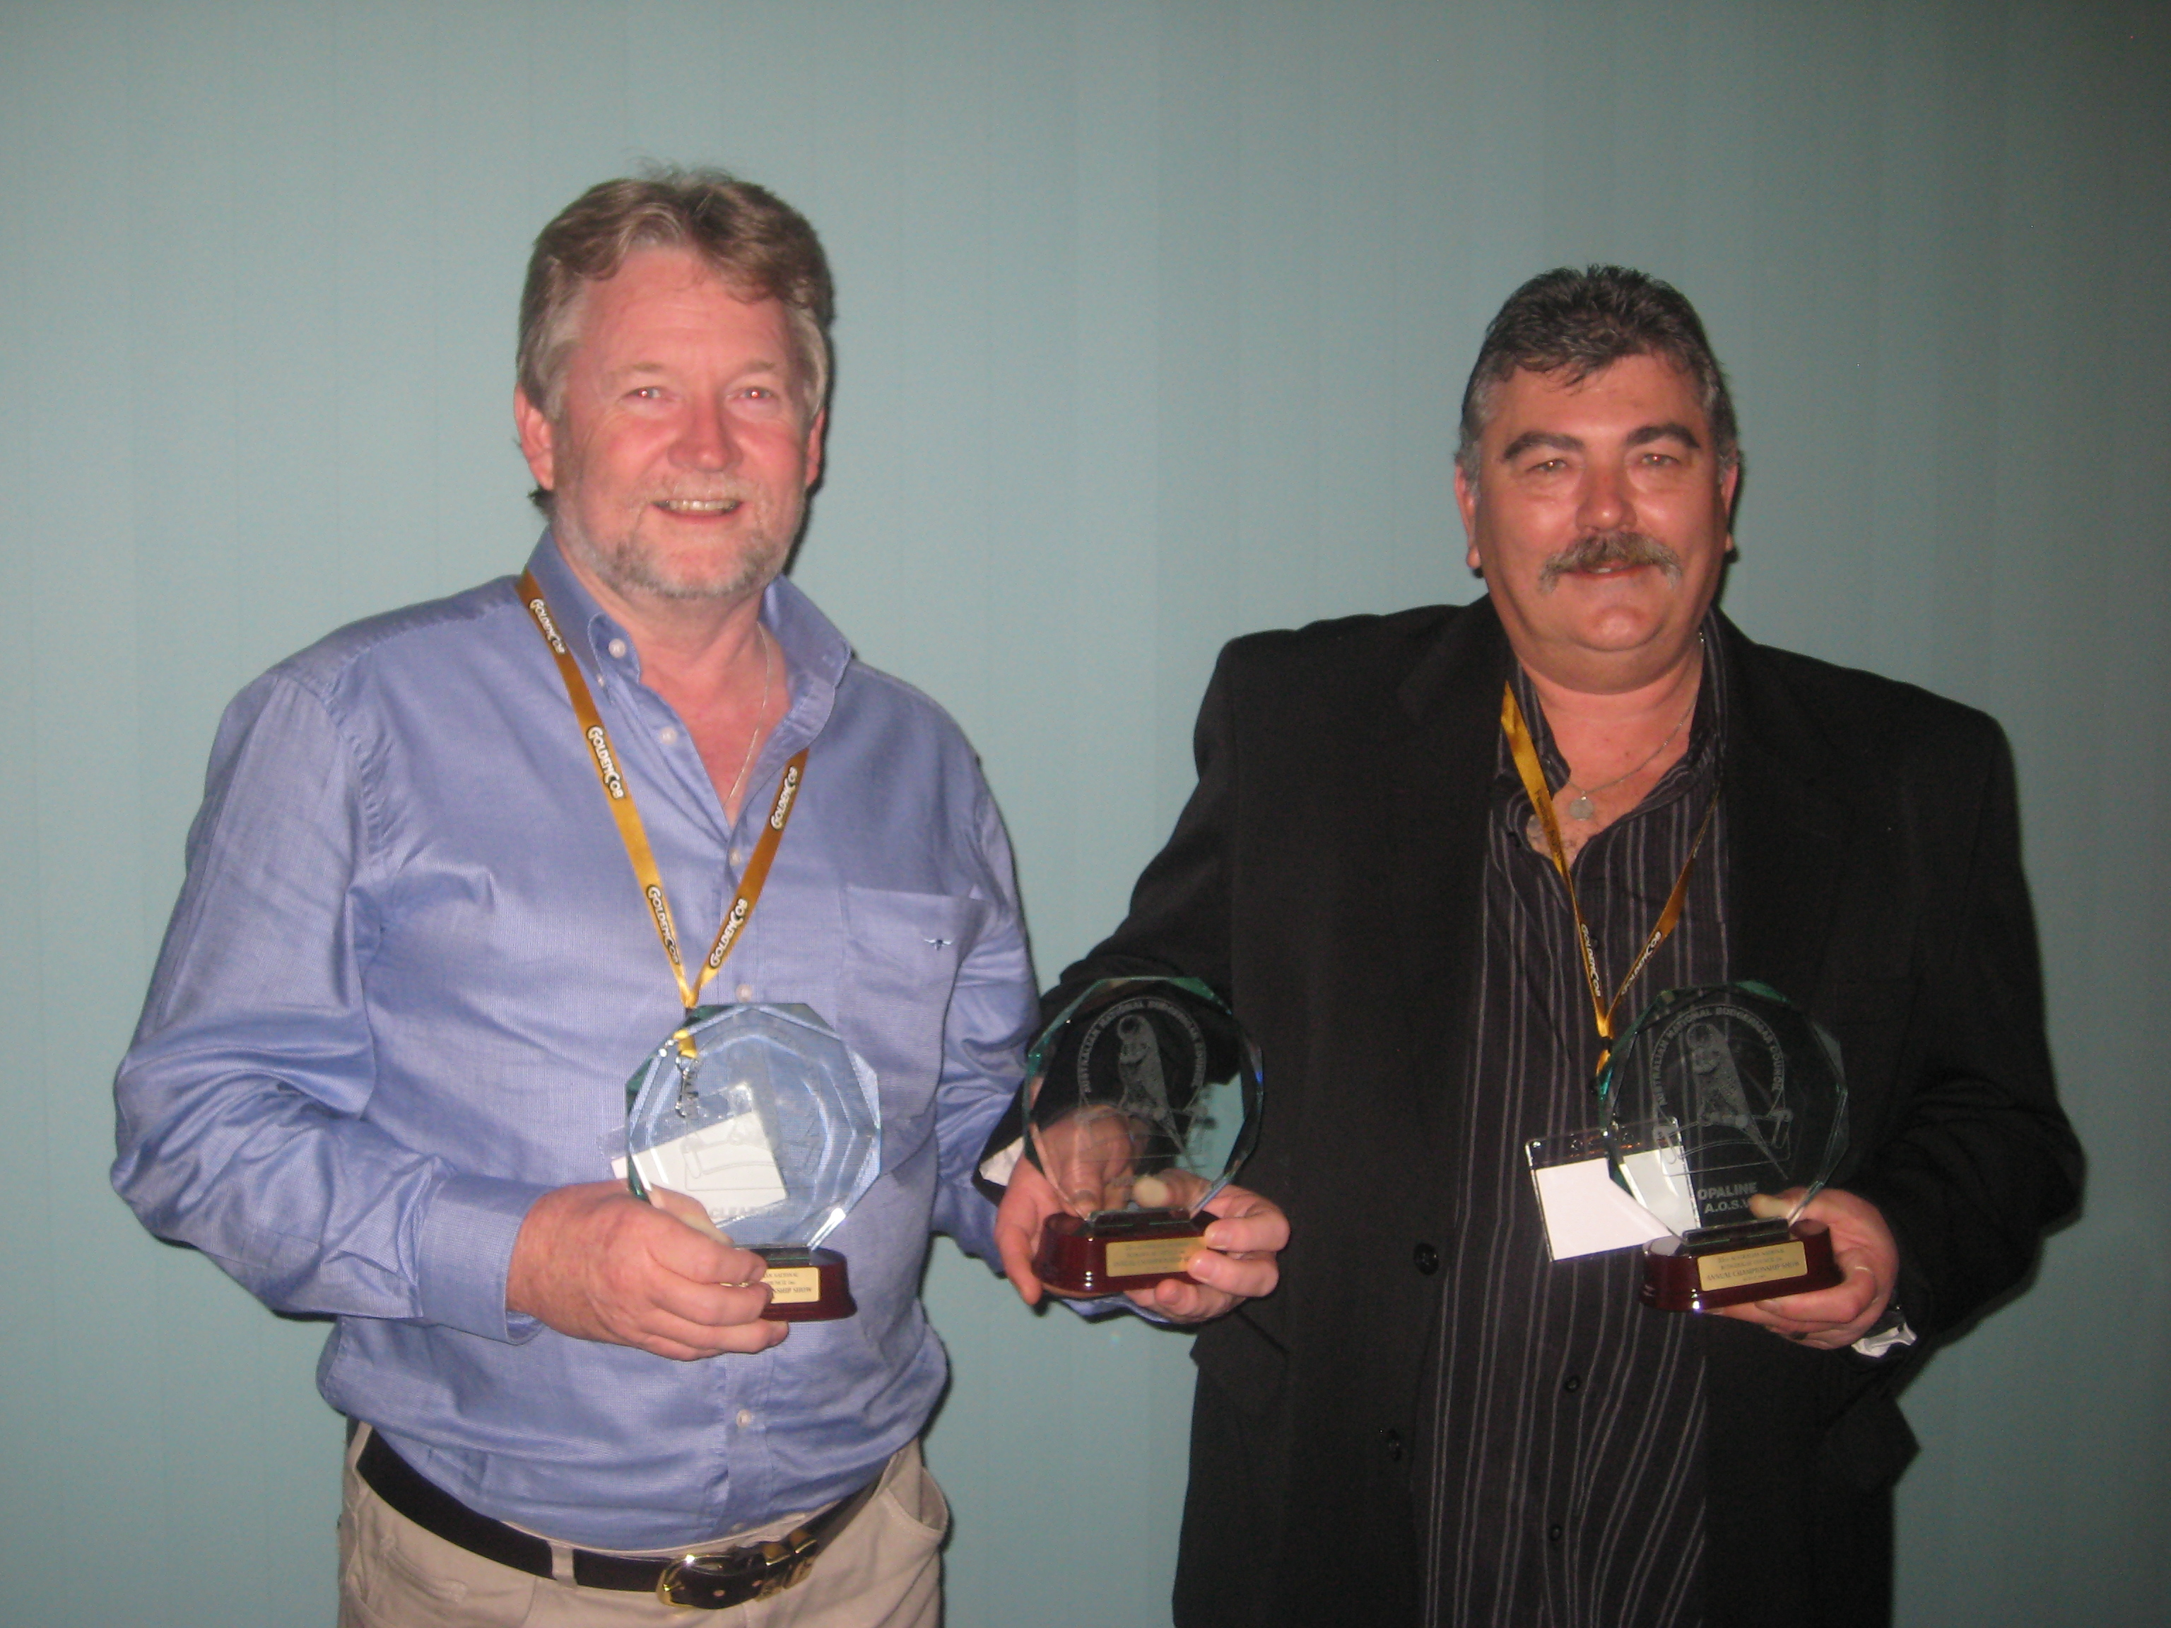
The limited numbers of birds that came in from the UK really restricted the flexibility for the two as you divide some nine birds into two separate sheds there is not a lot to work with.
Fortunately a few of the imported birds were prolific breeders, consistently producing strong shouldered birds, with great length of body, exceptional head feather and deep mask that were full of large spots.
Something that was plentiful in those early days was smaller type “cobby” hens. They exhibited really good conformation with no real faults other than being a little smaller.
And Colin believes that here lies one of the great secrets of the bird game.
The hen described in the last paragraph is a breeding type of hen, she is a hen that is bomb proof, will breed no matter what cock she is pared too, if you are to be successful first and foremost you must have birds that will breed for you no matter what the circumstances. You must have a line of hens that are full strong on fertility, feeding, nurturing and weaning.
Well-designed Bird Room and Aviaries are essential
There are literally a hundred matters to consider when constructing a bird room and aviaries, Bruce and Colin have gone down different paths here, Bruce has changed little of the bird room over the last forty years while Colin has relocated many times due to work commitments and has been continually building new bird rooms and aviaries every time he relocated. They both said the key considerations are:
- Face aviaries eastwards, so that birds can capture the morning sun daily
- Insulate the bird room against both the summer heat and the winter cold
- Clear roof panels can be painted white to reflect the heat and still allow light in, this has significantly reduced the sun from heating up the bird room
- It is essential that a bird room has good ventilation
- Aviary floors must never be permitted to get wet, they must remain dry
- Aviary lofts are a great way to feed vegetable and citrus foods that are damp and will be discarded and fall outside and not mix with droppings, this is now a common design feature for all of their aviaries
- Take care in the bird room layout to enure efficient daily routines, otherwise the routine will take time away from your birds and desire to improve the stud
- Fresh and clean drinking water must be convenient
- Cages and breeding boxes must be large and well ventilated
- Extending daylight utilising timers is essential for both the birds and the carer.
- Provide a 24 hour night light (15W pilot lamp) allowing birds to find the breeding box if disturbed at night
- A radio that provides a constant background of noise so that other bumps in the night are less of a threat
- A well sealed bird room will prevent mice from disrupting the breeding season and seed storage must be kept clear of fouling from mice etc.
- Hawks need to be kept from the outside wire, this can be easily achieved with shade cloth
- Vacuum aviaries weekly and clean bird room floors daily to keep the dust down
- Water and seed daily,
Feeding and maintaining our birds is critical
Feeding of quality budgerigars is a science according to Bruce and Colin, they both have a strong ethic in this area which has been developed over decades, they expect that their programs will continue to develop as more is understood.
- Seed, Premium Budgie, Daily
- A large variety of other seeds are provided on a regular basis
- Multi vitamins are a regular additive
- Soft food is not feed
- A wide range of vegetables and fruits are fed on a regular basis, offering something daily
- Clean Water Daily or more often in the summer months, Bruce prefers large drinkers in the loft, while Colin prefers large glass bowls on the floor.

The Breeding season
Management of the pairs during breeding season is very important if you are to maximise your opportunities and in turn produce more and more each season.
- Bruce and Colin refer to themselves as traditional breeders, that is they pair up on the Queens Birthday weekend in June, take two rounds, and in turn empty and clean out the bird room by the Christmas break
- Checking pairs twice a day is a minimum during the Breeding season
- Establishing foster pairs early, when you recognise some pairs are not feeding well enough, or too many chicks in the same nest the same age, or more than 4 chicks per pair, you need to start moving chicks to save them don’t hesitate.
- A strong culture of accurate record keeping is essential,
- You must repeat the same pairing each year if they continue to breed you great chicks or even a National winner each time, it may seem simple enough, but many breeders feel they can do better and change the pair?
- Trim feathers from both the Cock and Hen and if need be then in between rounds is equally important.

The real priorities in building a competitive Budgerigar
- Right back from the days of importation it was clear that the main feature of this stud was going to be strength of shoulder, and this key feature remains the highest priority for the partnership today.
- The bird must fill the cage and literally be a hand full,
- Mask and spot are very important and again need to be presented on the wide shoulders to catch their eye
- Birds must be truly representative of their respective variety
- Bruce & Colin consider that flecking has it’s place in the stud, and ticked birds are often shown when birds of the same quality but clean are not available, so flecking is very acceptable and can in fact be an advantage if managed well
- It is important to be ruthless with hens that do not perform, the hen is so important for the number of and size of eggs, fertility and feeding, you need to be able to trust the hen that you are about to put with your best Cock Bird. You also need to trust her with fledgling chicks while you are at work during the day.

